**FILE OPERATIONS**

**Description**

This module has several java actions which can be used in your application to manage file operations like create, delete, copy, move and get all files from directory.

It requires the directory path link and file name as the parameters.

**Typical usage scenario**

This can used in the projects where you need to handle the multiple files and folders and you wish to perform the file operations on them. Eg - To retrieve and show all the files to the user that are stored in a particular folder.

**PreRequisites**

NA

**Features and limitations**

* Create -This java action is used to create any type of file in a particular location (directory path)
* Delete - This java action is used to delete any type of file in a particular location (directory path) with given file name.
* Move - This java action is used to move any type of file from a particular location (directory path) to another.
* Copy - This java action is used to copy any type of file in a particular location (directory path) to another.
* GetAllFiles - This java action returns a list of files present in a particular folder or directory path.

**Dependencies**

* Requires Mendix 9.1.0 or above

**Installation**

1. Download the package from marketplace.
2. Import the module package into your project.
3. Directly use the java action in your microflows provide the directory path as the input parameter along with the file name.

**Screenshots**

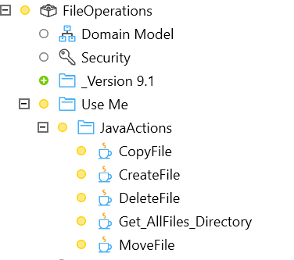

**Configuration: NA**

**Category: Module**

**Subcategory: All**

**Visibility: Public Marketplace**

**Studio Pro Version: 9.1.0**